**Case Study on NYPD Motor Vehicle Collisions**

**DATA VISUALISATON ASSINGMENT-1**

***By-***

**SAURABH KUMAR SINGH**

22201020070

Department of COMPUTER SCIENCE

UNITED UNIVERSITY

RAWATPUR, JHALWA

**BONAFIDE CERTIFICATE**

I certify that the project report titled "Case Study on NYPD Motor Vehicle Collisions," submitted to United University, Rawatpur, Jhalwa, is a genuine record of the work completed by Saurabh kumar singh under my supervision between the dates of April 15th, 2023, and April 25th, 2023.

**Mr. Kuldeep Gupta**

IBM Trainer & Teacher

**Mr. Prashant Shukla**

Head of Department

Computer Science

PRAYAGRAJ

24/04/2023

**DECLARATION**

I hereby declare that I, SAURABH KUMAR SINGH am the author of this report, and I affirm that none of its contents have been plagiarized from any other sources. Any information obtained from external sources has been appropriately cited and acknowledged. In the event that any section of this report is found to be plagiarized, I take full responsibility for it.

SAURABH KUMAR SINGH

22201020070

PRAYAGRAJ

24/04/2023

**TABLE OF CONTENTS**

|  |  |
| --- | --- |
| TOPIC NAME | PAGE NUMBER |
| Introduction to ibm and cognos | 1 |
| What is data module? | 2 |
| What is dashboard? | 3 |
| INTRODUCTION TO NYPD DATA MODULE. | 4 |
| PROBLEMS STATEMENTS. | 5 |
| SOLUTIONS OF PROBLEM 1 | 6 |
| SOLUTIONS OF PROBLEM 2 | 7 |
| SOLUTIONS OF PROBLEM 3 | 8 |
| SOLUTIONS OF PROBLEM 4 | 9 |
| SOLUTIONS OF PROBLEM 5 | 10 |
| SOLUTIONS OF PROBLEM 6 | 11 |
| SOLUTIONS OF PROBLEM 7 | 12 |
| SOLUTIONS OF PROBLEM 8 | 13-14 |
| SOLUTIONS OF PROBLEM 9 | 15-17 |
| SOLUTIONS OF PROBLEM 10 | 18-20 |
| CONCLUSTION | 21-24 |
|  |  |
|  |  |
|  |  |
|  |  |
|  |  |
|  |  |
|  |  |
|  |  |
|  |  |

**Introduction to the TOOL that is used in this report:**

IBM Cognos is a business intelligence and performance management software suite that provides tools for reporting, analysis, scorecarding, and monitoring of key performance indicators. It allows organizations to extract valuable insights from their data to make informed decisions and gain a competitive advantage in their respective markets.

Cognos is a web-based tool that can be accessed from anywhere, and it is designed to integrate with other data sources and applications, making it an excellent choice for enterprises with complex IT ecosystems. It can also be used by small and mid-sized businesses who need to manage their data and analyze it effectively.

IBM Cognos consists of several components, including Cognos Analytics, Cognos Planning, Cognos Controller, Cognos Disclosure Management, and Cognos Insight. Each component serves a specific purpose and provides unique features and functionalities to help organizations achieve their business objectives.

Overall, IBM Cognos is a comprehensive business intelligence solution that helps organizations to transform their data into actionable insights, improve decision-making, and drive business growth.

What is Data Module in IBM COGNOS?

In IBM Cognos, a Data Module is a metadata layer that provides a unified view of data from various sources, such as databases, spreadsheets, and web services. It is a tool that allows business analysts and report authors to prepare and enrich data for reporting and analysis without the need for complex SQL queries or ETL processes.

Data Modules enable users to access data from multiple sources and create a single data model that is optimized for reporting and analysis. Users can join, transform, and cleanse data, and create calculated columns and measures using a drag-and-drop interface, without requiring deep technical expertise.

Additionally, Data Modules provide a semantic layer that maps business concepts to technical data elements. This makes it easier for business users to understand and navigate the data and reduces the risk of data inconsistencies across reports.

Data Modules are designed to be reusable, making it easy to share them across the organization and reduce the duplication of efforts. They can also be scheduled to refresh data at specified intervals or triggered based on certain events.

Overall, IBM Cognos Data Modules provide a flexible and powerful way to prepare and manage data for reporting and analysis helping organizations to gain insights from their data more quickly and efficiently

**What is DASHBOARD in IBM COGNOS?**

IBM Cognos is a suite of software tools designed for business intelligence and performance management. Among its tools is the Data Dashboard, an online interface that provides access to essential metrics and key performance indicators (KPIs) for real-time analysis and reporting.

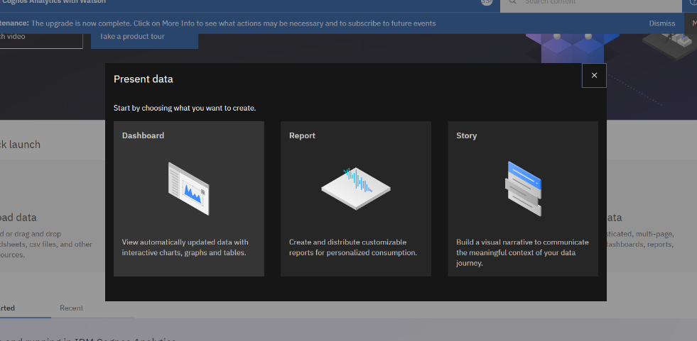

Users can create and personalize their own Data Dashboards in IBM Cognos by selecting from various pre-built widgets and data visualizations, such as graphs, gauges, tables, and charts. This allows for a customized and easy-to-interpret view of the data, enabling users to swiftly identify patterns, trends, and outliers. The widgets can be arranged and resized as per the user's preference, resulting in a tailored view of the data that is most relevant to their needs.

Overall, the Data Dashboard in IBM Cognos provides a powerful, user-friendly interface for monitoring and analysing key metrics and KPIs, enabling organizations to make more informed decisions and achieve better business outcomes.

INTRODUCTION OF DATA MODULE IN THIS REPORT:

**NYPD MOTOR VEHICLE COLLISIONS**

The **NYPD Motor Vehicle Collisions** **dataset** is a collection of data **related to motor vehicle accident**s that occurred **in New York City**. This dataset includes information about the date and time of the accident, the location of the accident, the type of vehicle involved, and the severity of the accident, among other things.

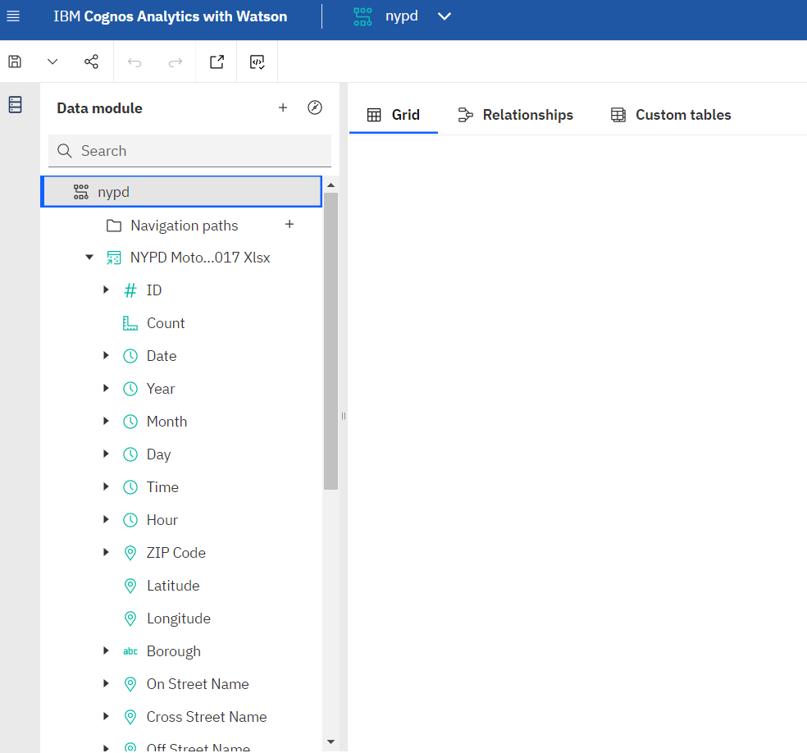

**IBM Cognos** is a business intelligence tool that allows users to analyse and report on data. The NYPD Motor Vehicle Collisions dataset **can be imported into Cognos as a data module**, which is a container for data assets that can be used to create reports and analyses. Once the data module is created, users can explore the data, create visualizations, and **generate reports to gain insights into the patterns and trends** in motor vehicle collisions in New York City.

# Problem Statements Based on NYPD MOTOR VEHICLE COLLISIONS

**Standard Problems:**

1- You have to show the total number of "total injury/total killed".

2 - Show the following Summary from Total Injury Number, Pedestrian Injured, Cyclist Injured and Motorcyclist Injured.

3- Show the Injuries on the basis of Year.

4- Show the number of Injuries on the basis on "vehicle 1 contribution factor", "vehicle 2 contribution factor" and "vehicle 3 contribution factors".

**Scenario Based Problems:**

5- Give the number of pedestrian/cyclist/motorists injured for on the basis on any particular city, month and year.

6- Give the map view of any city street where accident injury rate is high.

7- Give the total number of injuries on the basis on month in a crosstab.

8- New York Animal Welfare Department wants to subdue the rate of accident due to Animal accident factor. Tell them which particular city and on which particular street they have to focus on.

9- New York Traffic Department wants to spread the traffic awareness knowledge to some local citizens who are not properly aware about the rules. Help them from which city and street they start and why?

10- New York Road Authority wants to create some new street lane for more than 6 tiers vehicle so, suggest any Top 7 locations in New York in which they can build a new lane for heavy vehicles and why?

**SOLUTIONS OF PROBLEM STATEMENTS**

**QUERY 1**- Here we show the total number of **"total injury/total killed".**

**ANSWER**- dashboard view

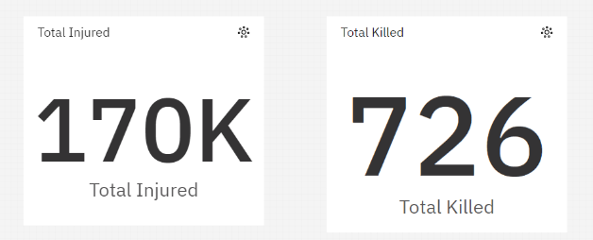

**STEPS-**

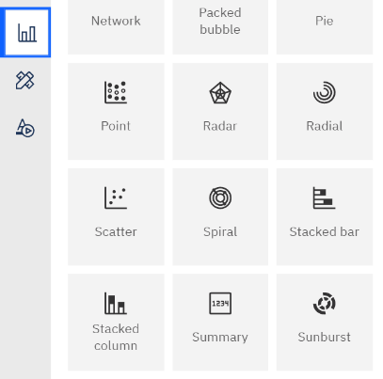 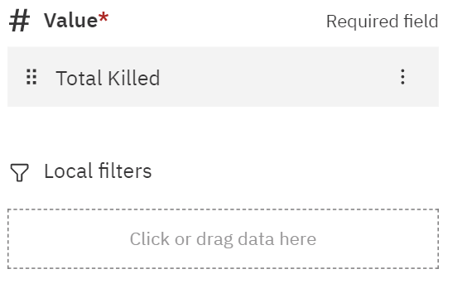

*CLICK ON VISUALIZATION> DOUBLE CLICK ON SUMMARY TOOL> IN VALUES SELECT TOTAL KILLED AND SAME WITH TOTAL INJURED.*

**QUERY 2** -Show the following **Summary** from Total Injury Number, Pedestrian Injured, Cyclist Injured and Motorcyclist Injured.

**ANSWER- DASHBOARD VIEW**

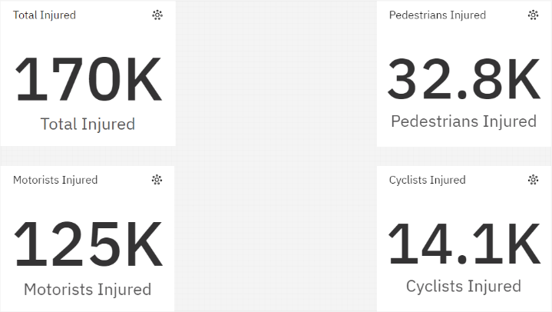

**STEPS-**

 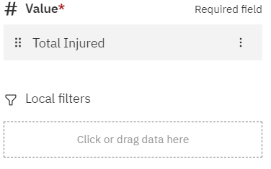

CLICK ON VISUALIZATION> DOUBLE CLICK ON SUMMARY TOOL AND REPEAT THE SAME FOR 4 TIMES > NOW IN VALUES SELECT TOTAL INJURED, PEDESTRIANS INJURED, MOTORISTS INJURED AND CYCLISTS INJURED RESPECTIVLY.

**QUERY 3**- Show the **Injuries** on the basis of **Year**.

**ANSWER-** DASHBOARD VIEW

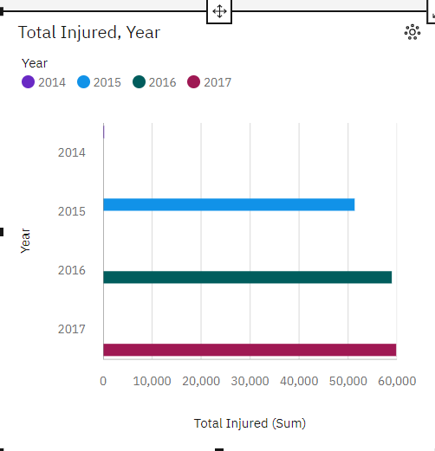

**STEPS-**

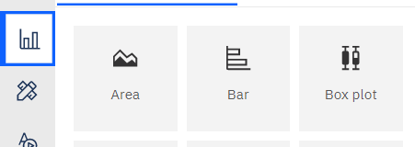 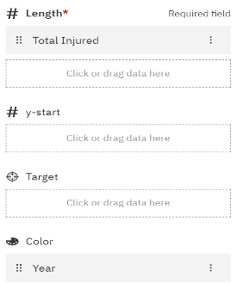

CLICK ON VISUALIZATION> DOUBLE CLICK ON BAR TOOL> NOW IN LENGTH SELECT TOTAL INJURED AND IN COLOUR CHOOSE YEAR.

**QUERY 4**- Show the number of **Injuries** on the basis on **"vehicle 1 contribution factor", "vehicle 2 contribution factor"** and **"vehicle 3 contribution factors".**

**ANSWER-** DASHBOARD VIEW

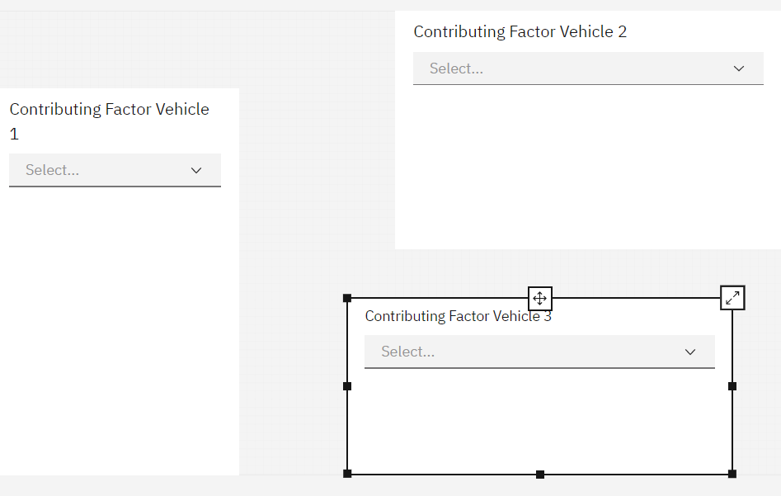

**Steps-**

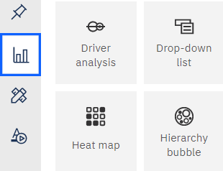 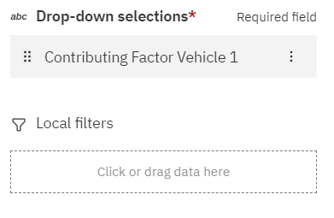

CLICK ON VISUALIZATION> DOUBLE CLICK ON DROP DOWN TOOL AND REPEAT THE SAME FOR 3 TIMES > NOW IN VALUES SELECT CONTRIBUTING FACTOR VEHICAL 1, CONTRIBUTING FACTOR VEHICAL 2 AND CONTRIBUTING FACTOR VEHICAL 3 RESPECTIVLY.

**QUERY 5**- Give the number of **pedestrian/cyclist/motorists** injured for on the basis on any particular city, month and year.

**ANSWER-** DASHBOARD VIEW

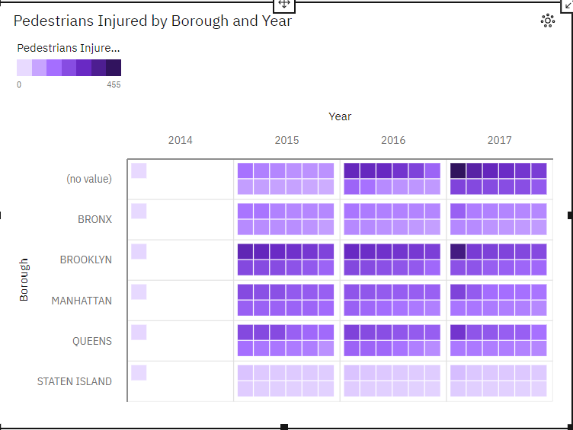

***INFORMATION ABOUT THIS HEAT MAP:***

X axis its showing years

Y axis its showing cities as borough

And in centre it showing total pedestrians injured in which every block denotes the months.

**Steps-**

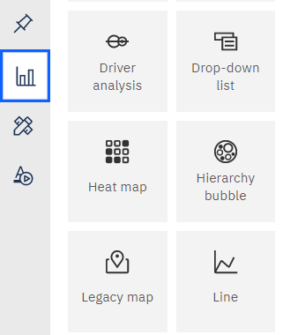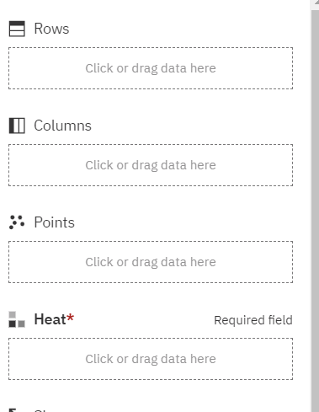

CLICK ON VISUALIZATION> DOUBLE CLICK ON HEATMAP TOOL> IN THE FIELDS ADD BOROUGH IN ROWS, YEARS IN COLOUMNS, MONTHS IN POINTS AND PEDESTRIANS INJURED> REPEAT THE SAME FOR CYCLISTS AND MOTORISTS.

**CONCLUSTION OF THIS HEATMAP:**

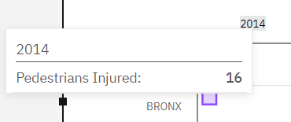 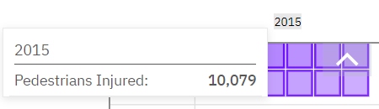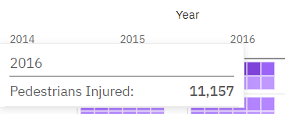 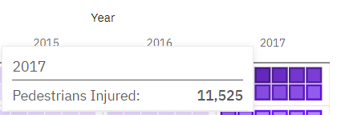

**QUERY 6**- Give the **map view** of any city street where accident injury rate is high.

**ANSWER-** DASHBOARD VIEW

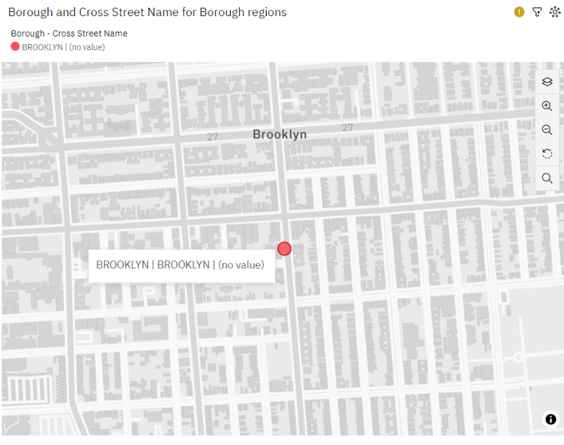

**STEPS-**

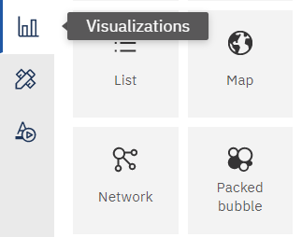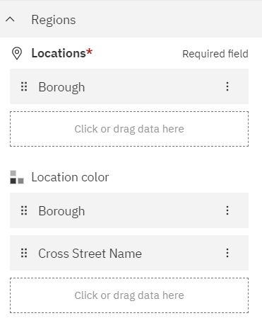

CLICK ON VISUALIZATION> DOUBLE CLICK ON MAP> IN FIELDS FILL BOROUGH IN LOCATIONS THEN IN LOCATION COLOUR FILL BOROUGH AND CROSS STREET NAME> THEN IN THE BOTTOM OF FIELDS THERE IS FILTER OPTION> IN THAT FILL TOTAL INJURED YOU WILL BE SHOWN THE STREET VIEW WHERE MOST NUMBER OF ACCIDENTS HAPPENED AS PER THE INJURY RATE.

**QUERY 7**- Give the total number of **injuries** on the basis on **months** in a **crosstab**.

**ANSWER-** DASHBOARD VIEW

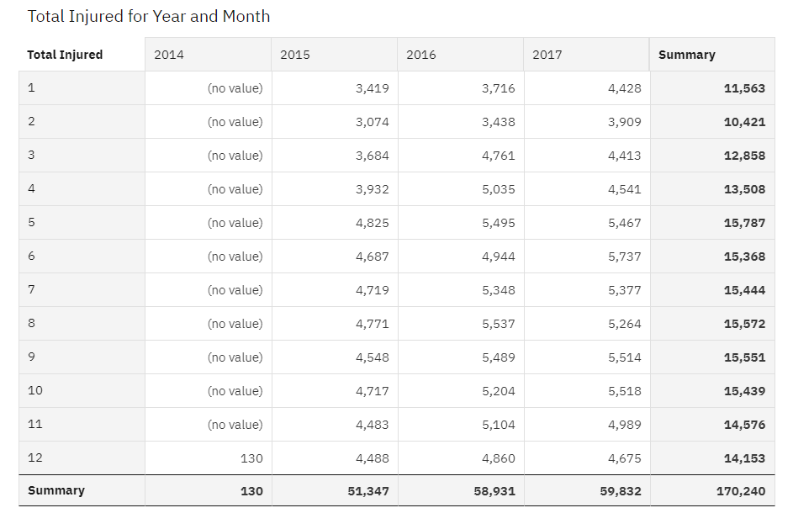

**STEPS-**

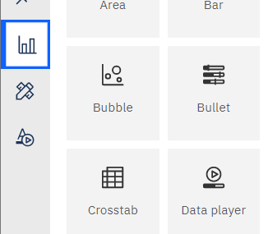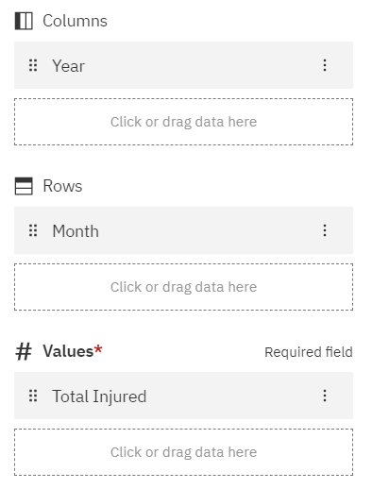

CLICK ON VISUALIZATION> DOUBLE CLICK ON CROSSTAB TOOL> IN FIELDS FILL YEARS IN COLUMNS JUST FOR BETTER UNDERSTANDINGS> MONTH IN ROWS AND TOTAL INJURED IN VALUES.

**QUERY 8**- New York Animal Welfare Department wants to subdue the rate of accident due to **Animal accident factor**. Tell them which particular city and on which particular street they have to focus on.

**ANSWER-** DASHBOARD VIEW

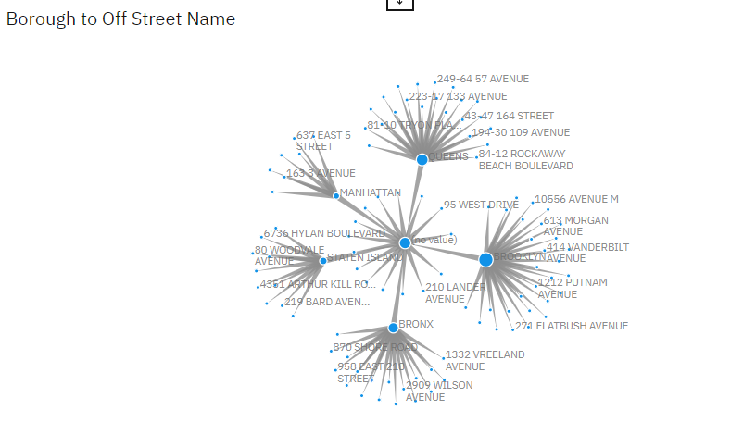

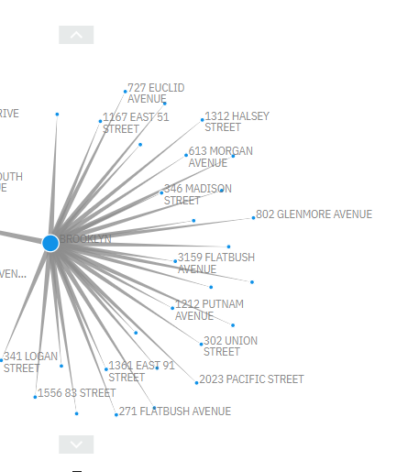

**STEPS-**

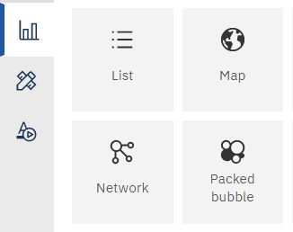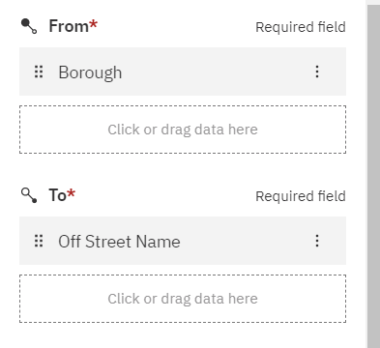

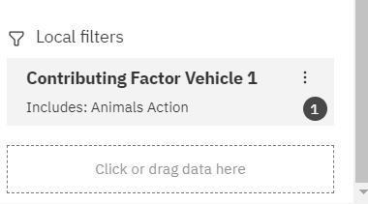

CLICK ON VISUALIZATION> DOUBLE CLICK ON NETWORK TOOL> IN FIELDS FILL BOROUGH IN FROM AND OFF-STREET NAME IN TO> THEN IN LOCAL FILTERS ADD CONTRIBUTING FACTOR VEHICLE 1.

**QUERY 9**- New York Traffic Department wants to spread the **traffic awareness knowledge** to some local citizens who are not properly aware about the rules. Help them from **which city and street they start** and why?

**ANSWER-** WITH THE HELP OF DROP-DOWN TOOL AND NETWORK TOOL WE WILL GET THE INFORMATION ABOUT INJURIES WHICH ARE HAPPENING DUE TO LACK OF KNOWLEDGE OF TRAFFIC RULES.

**DASHBOARD VIEW:**

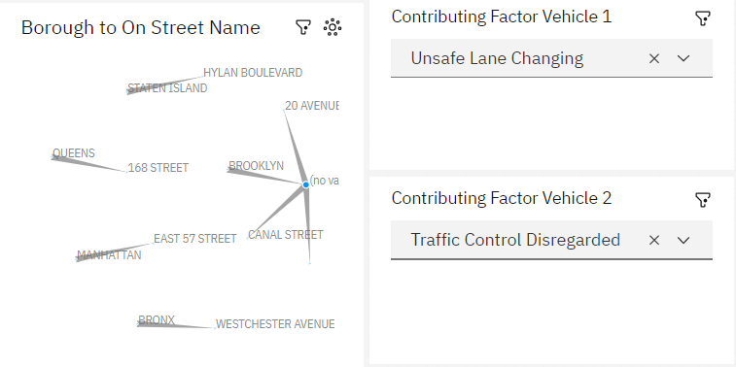

**STEPS-**

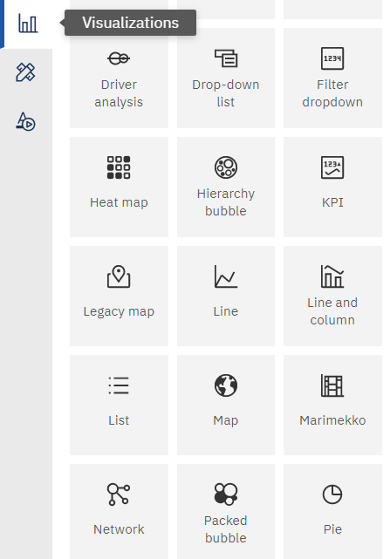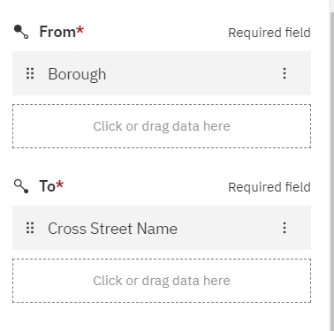

CLICK ON VISUALIZATION> DOUBLE CLICK ON NETWORK TOOL> NOW AGAIN FROM VISUALIZATIONIN PICK 2 DROPDOWN TOOLS WITH SELECTING CONTRIBUTING VEHICLES 1 AND VEHICLE 2> THEN IN FIELDS OF NETWORK TOOL FILL BOROUGH IN FROM AND CROSS STREET NAME IN TO.

**QUERY 10**- New York Road Authority wants to create some **new street lane** for more than **6 tiers vehicle** so, suggest any Top 7 locations in New York in which they can build a new lane for **heavy vehicles** and why?

**ANSWER-** They should construct new street lane from any of the following location of New York as shown in screenshot as, these are the location where most of the people got injured due to the heavy traffic by large com vehicles and short roads.

**DASHBOARD VIEW:**

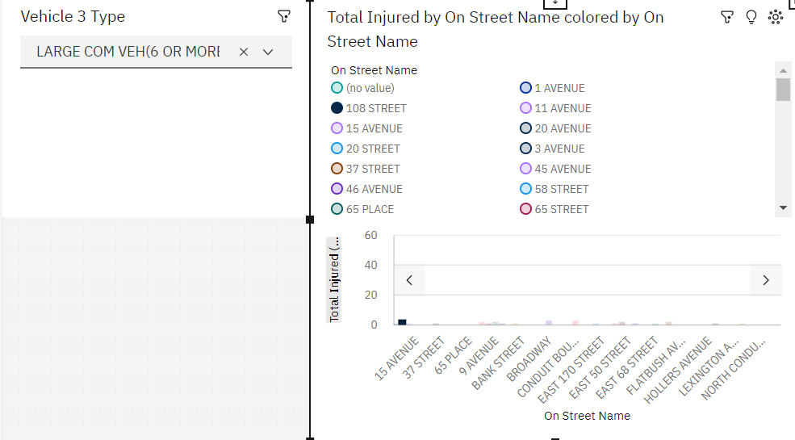

**STEPS-**

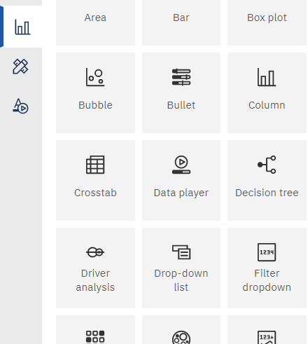 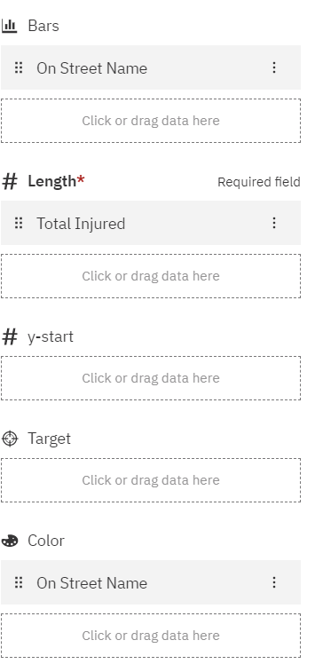

CLICK ON VISUALIZATION> DOUBLE CLICK ON DROPDOWN AND COLOUMN TOOL> IN FIELD OF DROPDOWN TOOL FILL LARGE COM VEH (6 OR MORE TIRES)> THEN IN FIELDS OF COLOUMN TOOL FILL ON STREET NAME IN BARS, TOTAL INJURED IN LENGTH AND ON STREET NAME IN COLOUR.

**CONCLUSTION:**

Valuable information on traffic accidents that take place on the streets of New York City can be found in the NYPD Motor Vehicle Collisions dataset. By utilizing IBM Cognos, a powerful business intelligence tool, this data can be analyzed to uncover insights that can aid in improving road safety and reducing the frequency of accidents.

### A common issue that IBM Cognos can tackle is the display of the overall count of injuries and fatalities resulting from traffic accidents. This data can be used to detect patterns and trends in accident data, which can then be utilized to create effective strategies aimed at reducing the number of injuries and fatalities.

IBM Cognos can also address the standard problem of summarizing injuries by road user type, such as pedestrian, cyclist, and motorcyclist. This summary can be used to identify the most vulnerable road users and develop targeted safety campaigns and initiatives to improve their safety.

Analyzing injuries by year is another typical issue that IBM Cognos can handle. This data can be used to recognize patterns and trends in accident data, allowing for the development of effective strategies aimed at reducing the number of accidents occurring on New York City streets.

Another standard issue that can be tackled with IBM Cognos is analyzing injuries by vehicle contribution factors. This information is essential for identifying the factors that contribute to accidents and for devising strategies aimed at reducing the number of accidents that occur on New York City streets.

Moreover, IBM Cognos can be used to solve scenario-based problems, such as providing the number of pedestrian/cyclist/motorists injured for a specific city, month, and year. This information can be used to recognize high-risk areas and to create safety initiatives that are specifically targeted towards them.

Using IBM Cognos, it is possible to address various scenario-based problems related to road safety. For instance, one can display a city street map with a high rate of accident injuries, which can help identify dangerous intersections and develop targeted safety measures to reduce the number of accidents in those areas.

Another scenario-based problem that can be addressed using IBM Cognos is to create a crosstab that shows the total number of injuries on a monthly basis. This information can be used to identify accident trends and patterns, which can be helpful in developing strategies to reduce the number of accidents on the streets of New York City.

Using IBM Cognos, it is possible to address scenario-based problems such as identifying high-risk areas in a city and street where animal accidents occur frequently. This information can be used to develop targeted safety initiatives and measures to reduce the number of accidents in these areas.

Another scenario-based problem that can be addressed using IBM Cognos is recommending a city and street to start a traffic awareness campaign. This information can be used to identify areas where drivers lack awareness of road rules and develop targeted safety campaigns to improve driver awareness and reduce accidents.

Another possible scenario-based problem that can be addressed using IBM Cognos is identifying locations with high levels of traffic congestion during peak hours. By analysing this data, city planners can recommend new road layouts or targeted initiatives to alleviate congestion and reduce the number of accidents that occur on the streets of New York City.

In conclusion, the NYPD Motor Vehicle Collisions dataset provides a valuable resource for identifying trends and patterns in accident data, which can be used to develop targeted safety initiatives to create safer streets for all road users. By leveraging the power of IBM Cognos to analyse this data, we can work towards reducing the number of accidents and improving road safety in New York City.